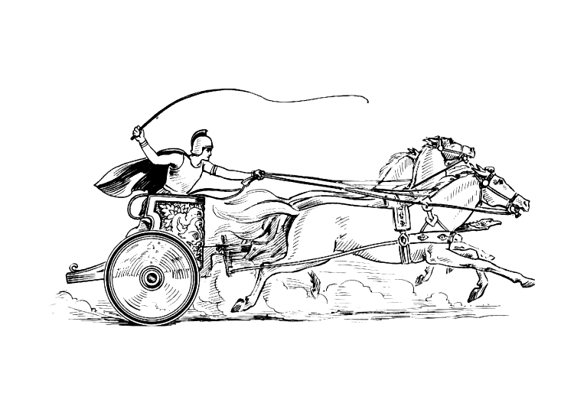 Manduessedum - Mancetter Village (Place of War Chariots)

Mancetter Parish Council
Serving the People of Mancetter and Ridge Lane

PARISH COUNCIL MEETING
OF THE PARISH OF MANCETTER

Minutes of the Parish Council Meeting of the Parish of Mancetter,
held on Tuesday 1st August 2023 at Ridge Lane Chapel and Community Room,
commencing at 7pm.

Present:
Chairman Mr T Hopkins.

Parish Councillors Mr H Blackburn, Mrs G Forknall, Mr J Tither, Mrs N Wallis.

Borough Councillor Mr K Barnett.

Parish Clerk Mrs E Higgins.

Item 1 - Welcome and Apologies

Mr T Hopkins welcomed everyone to the meeting.

Apologies had been given by Parish Councillors Sue Healy due to a medical appointment and Peter Mann due
to illness. These apologies were accepted.

Borough and County Councillors Denise Clews and Margaret Bell had to attend other meetings, as this one
was taking place a week later than usual, due to unavoidable personal circumstances.

There was no representation from the police.* Following the meeting PCSO Emily Jenkins sent through a
mini report which is included in Item 5.

Item 2 – Recording of the meeting.

There was no recording of the meeting.

Item 3 – Notice of Interest.

There were no notices of interest declared.

Item 4 – Public Question Time.

There were no members of the public present at this meeting.

Item 5– Update from Police, County and Borough Councillors.

Police

Good morning,

Apologies I did not make the meeting on Tuesday, I was due to attend but got stuck at a job!
Below is a mini report.

Good news
Junior PCSO Scheme at Outwoods Primary School, ASB hotspot patrols - parks , Home visits to regular ASB children, Crime prevention day at Mancetter rec, Kirby Glebe site visited and engaged, Process of serving Sec 59 for ASB vehicle, Process of serving CPN for shoplifting, Laurel Garden coffee morning.
Incidents
ASB – 2, Domestic – 5, Silent 999 – 8, Violence – 4, Abandoned vehicle – 1, Sexual offence – 1, Animal – 6, Sus circs – 8, Concern – 6, Misper – 2, RTC – 4, Road related – 10, Fire / arson – 1 and Damage – 2.
Thanks Emily.
Borough Council
Borough Councillor Keith Barnett apologised for not being able to attend Mancetter Recreation Ground on the day of the attempted traveller encampment on 13th July, as he was at a meeting. He did contact the Clerk later that evening. Councillor Clews was away on holiday.

David Wright the Leader of the Borough Council did visit the site, that with support from the community and the efforts of Harry Blackburn, Trevor Hopkins and Elane Higgins, had been able to be secured to prevent a further attempt overnight.

The Police escorted the caravans out of the village.

Parish Councillor Harry Blackburn had prevented access by positioning his car across the main entrance. A dashcam photograph of the gentleman responsible for attacking the top barrier was given to Councillor Barnett, in case the Borough Council as owners of the field, wish to pursue the matter with the police.

Councillor Blackburn suggested a low cost deterrent to prevent padlocks from being cropped off by using a nut similar to those used to lock wheel trims.

There is a pattern to encampments at certain times of the year, so it is worth local authorities being aware of risks and locking gates.

The Chairman Trevor Hopkins asked Councillor Barnett, if there was any further information on the timescale for rearranging the cancelled appeal hearing for Barn Fishery, originally scheduled for 6th June 2023.

There was no feedback from the County Council due to the need to send apologies.

Item 6 – Minutes of the last meetings.

The draft minutes from the 16th May 2023 and 22nd June 2023 were proposed and seconded by Councillors and therefore formally signed by the chairman as a true record of proceedings.

The minutes of the formal parishioners meeting on 23rd May were approved and will be presented at the meeting in April 2024 for official signature.

Item 7 – Matters arising from the previous minutes / Issues not covered in any other agenda points.

- Appointment of Vice Chair and Update on Parish Council Vacancy

Parish Councillor Harry Blackburn with the unanimous support of the council, agreed to take on the role as vice chair of the parish council for the rest of this year of office. He had signed the declaration book prior to this meeting and subsequently submitted the relevant declaration of interests and code of conduct documents to the clerk.

As the Clerk has holiday booked for August, it was agreed to make a concerted effort to fill the remaining parish councillor vacancy and re-advertise from the beginning of September.

- Update on installation of subsidiary cemetery water supply, replacement of Jubilee Avenue trees, Coronation floral planting and dog fouling signage at Ridge Lane.

The Parish Handyman and Chairman worked together on installing a water bowser behind the screened area within the current burial and cremation areas.

A 100 metre hose is tucked away and used to fill the bowser when rainfall levels are insufficient.

Positive comments have been received from parishioners who no longer need to carry water from the top of the cemetery. It has also proved useful when watering the trees planted to form the Jubilee Avenue.

The three replacement trees have been planted successfully, and it is now time to release bands around the stakes of the first six trees in the avenue, planted in 2012 for the Diamond Jubilee.

Trevor Hopkins and Barry Stevenson worked together again to lay out the floral display of marigolds on the village green in Mancetter in the shape of a crown and the cipher of King Charles III.

Together with the raised beds in Ridge Lane, the parish is continuing to be colourful outside of daffodil and tulip seasons.

The laminated dog fouling signs placed upon the lamp posts around the Ridge Lane recreation ground are beginning to show signs of wear. Permission for permanent official signage will be requested.

- Feedback from the County Council Road Safety Team and Traffic Survey

There has been no progress since the attendance of Graham Stanley and Jeff Morris at the parishioners meeting on 23rd May 2023.

- Progress Report on Levelling Up, Climate Change and Cost of Living agendas

Staff from Warwickshire County Council have met at Mancetter Memorial Hall to park up, and then gone out to conduct a door knocking initiative to obtain feedback for a questionnaire on life within Mancetter and Ridge Lane villages as part of the first phase of the Levelling Up process.

The County Council have also sent through some Climate Change Posters to display within our communities.

Cost of living information and advice is regularly sign posted on the parish council’s social media page and website.

Item 8 – Finance

- Two councillors signed the financial paperwork since the last meeting in accordance with Standing Orders and the Bank Mandate.

Following the approval of the Annual Return and Governance Statement, notices were posted and paperwork submitted to the External Auditor.

- A letter had been drafted to HSBC to formally request the removal of the retired Assistant Finance Clerk from the mandates, and to install Mrs E Higgins as the primary user for the purposes of internet banking. It was agreed unanimously to submit this paperwork to the relevant departments, together with a copy of the minute reference.

- A lengthy discussion took place concerning the cost of replacing the Parish Council Noticeboard on the corner of Manor Road in Mancetter. Design options and materials to be used were considered. It was proposed by John Tither and agreed by the council to defer a decision until more research can be done on costings and options.

- It was agreed unanimously for the Chairman’s discretionary payment to be made this year to Girlguiding Atherstone District for their involvement in providing refreshments for the informal meeting of parishioners on 20th September 2023.

- A report on income and expenditure from 1st April 2023 – 30th June 2023 was distributed to councillors to monitor the current figures against the budget. As the computer divides the overall budget between the four quarters of the financial year, it can show an under or overspend which will adjust itself throughout the year.

Item 9- Planning Matters and New Applications since the previous meeting.

- Update on Approved, Rejected and Pending Applications and Appeals.

The outcome of applications listed on the agenda were duly noted, with submissions for Mancetter Marina and the appeal hearing for Delamere still pending. Approval has been granted for Canal Cottage and Whitehall Farm. The application for Cherry Tree Farm will take place under permitted development.

- New Applications received.

- PAP/2023/0229 – Mancetter Wharf – Erection of Office Building including landscaping and parking. – Comments to be submitted regarding traffic flow and drainage. Parking needs to be contained within the site.

- PAP/2023/0280 – Sovereign Motor Company – Proposed extension to existing vehicle workshop to be used as an MOT facility.
- PAP/2023/0283 – Sovereign Motor Company – Change of use for part of site to vehicle sales.

The Council encourages diversification to safeguard businesses in these challenging times. However due to the site being across the road from the main industrial area, space is limited and parking for car sales and visitors may cause issues on Manor Road. Councillor Blackburn will have a look at the site and feedback comments.

- PAP/2023/0299 – 12 Mancetter Road – Demolition of existing conservatory and construction of a new rear extension – No Objection.

Item 10 – Date of Next Meeting:

Informal Parish Meeting for Residents and Local Community Groups
Wednesday 20th September 2023 7pm at Mancetter Memorial Hall.

As there was no further business the meeting closed at 9.35pm
Manduessedum - Mancetter Village
(Place of War Chariots)
Mancetter Parish Council
Serving the People of Mancetter and Ridge Lane

